VILLAMIN WOOD AND IRON WORKS ONLINE STORE

Project Documentation Submitted to the Faculty of the

School of Computing and Information Technologies

Asia Pacific College

In Partial Fulfillment of the Requirements for

Systems Analysis and Detailed Design for IT

MSYADD1

By

*Camara, Leigh Curtis* *B.* *Angeles, Ludwig Marco T.*

*Aspeli, Mabelle* *T.* *Calderon, Felino III E.*

*Domingo, Dale Joshua* *B.* *Sison, Nathaniel M.*

*Villamin, Sofia Emmanuelle R.*

ASIA PACIFIC COLLEGE

Approval Sheet

Villamin Wood and Iron Works System

Prepared and submitted by

*Camara, Leigh Curtis* *B.*  *Angeles, Ludwig Marco T.*

*Aspeli, Mabelle* *T.* *Calderon, Felino III E.*

*Domingo, Dale Joshua* *B.*  *Sison, Nathaniel M.*

*Villamin, Sofia Emmanuelle R.*

In Partial Fulfillment of the Requirements for the Degree of

Bachelor of Science in Information Technology

Examined and Recommended for Acceptance and Approval for

Research/Capstone Presentation

___________________________

Mr. Jojo Castillo, Adviser

Panelists

___________________________

Ms. Roselle Gardon, Chairperson

|  |  |
| --- | --- |
| ___________________________ | ___________________________ |
| Dr. Manuel Calimlim Jr., Panel Member | Mr. Bernardino Roda, Panel Member |

Acceptance and Approved in Partial Fulfillment of the Requirements for the Degree of

Bachelor of Science in Information Technology

___________________________

Rhea-Luz R. Valbuena

Executive Director

School of Computing and Information Technologies

Table of Contents

Executive Summary i

List of Figures ii

List of Tables iii

Introduction 1

Project Context 1

Statement of the Problem 2

Objectives 3

Significance of the Project 4

Scope and Limitations 4

Review of Related Literature / Systems 6

Technical Background 11

Current System 11

Proposed System 11

Methodology 13

Requirements Analysis 15

Product Backlog / User Stories 15

Event Tables 16

Use Case Diagram 17

Use Case Full Description 18

Gap Analysis 22

System Analysis and Design 22

Context Flow Diagram 22

Data Flow Diagram 23

Entity-Relationship Diagram 24

Activity Diagram 25

Object Diagram 26

Class Diagram 27

Sequence Diagram 28

State Machine Diagram 30

Package Diagram 31

Component Diagram 32

Deployment Diagram 33

Results and Discussion 34

Release Plan 34

Prototype 35

Use Classes and Characteristics 39

Conclusion 40

References 42

Appendices 43

Appendix A: Project Vision 43

Appendix B: Schedule 44

Appendix C: Product Roadmap 45

Appendix D: Users’ Manual 46

Appendix E: Team Meetings 51

Appendix F: Source Code 52

# Executive Summary

Villamin Wood & Iron Works has proven to be durable when it comes to its products. One of their best products is their solid wooden doors which are made of hardwood and come with affordable prices, quality, and excellent workmanship. In 2017, they expanded their business by using a Facebook Page. That is why even though it has been established in 1983, it is still alive and profitable up until now.

Their Facebook page is a tool they use to gain new customers, but in the last five years, they have gained few followers, which is a sign that fewer people can see their Facebook page changes and posts in their News Feed. That is why it is so unfortunate because they did not manage it well. For the reason of overloaded work of the store manager, their income significantly affected. In this case, they need a solution (online store) with an attribute that will eventually help them acquire customers and boost their revenue in some way.

Sales of the online products in the Philippines surpassed $17 billion in 2021, with 73 million active online users accounting for a substantial portion of that figure. Through 2025, a growth of 17% is expected to bring this to an estimated $24 billion. The developers concentrate on creating an online store to sell, which would help the company to increase their online presence. With this solution, the team hopes to increase revenue by at least 50% starting in the first year of their online operations.

# List of Figures

Figure 1. Agile Methodology Cycle 13

Figure 2. Use Case Diagram 17

Figure 3. Context Flow Diagram 23

Figure 4. Level 0 - Data Flow Diagram 23

Figure 5. Level 1 - Manage Order (Customer) Data Flow Diagram 24

Figure 6. Level 1 - Manage Account (Customer) Data Flow Diagram 24

Figure 7. Entity-Relationship Diagram 25

Figure 8. Activity Diagram 26

Figure 9. Object Diagram 27

Figure 10. Class Diagram 27

Figure 11. Sequence Diagram for Store Owner 28

Figure 12. Sequence Diagram for Store Manager 28

Figure 13. Sequence Diagram for Customer Account 29

Figure 14. Sequence Diagram for Customer Inquiry 29

Figure 15. Sequence Diagram for Ordering 30

Figure 16. Sequence Diagram for Feedback 30

Figure 17. State Machine Diagram for Customer Inquiry 30

Figure 18. State Machine Diagram for Manage Account 31

Figure 19. State Machine Diagram for Manage Orders 31

Figure 20. State Machine Diagram for Store Owner Manages Website 31

Figure 21. State Machine Diagrams for Store Manager Manages Inventory and Admin View Dashboard Reports 31

Figure 22. Use Case Package Diagram 32

Figure 23. Component Diagram 32

Figure 24. Deployment Diagram 33

Figure 25. Website Home Page 35

Figure 26. Website Product Page (Existing Designs) 36

Figure 27. Website Product Page (Custom Design) 36

Figure 28. Website Customer Forum Page 37

Figure 29. Frequently Asked Questions (FAQs) Page 38

Figure 30. About the Company Page 39

Figure 31. MLNSD's Project Timeline 44

Figure 32. Search Results Page 46

Figure 33. Product Information Page 46

Figure 34. Product Cart Page 47

Figure 35. Edit Profile Page 48

Figure 36. Purchases Page 49

Figure 37. Login and Sign Up Page 50

Figure 38. Meeting with Adviser - September 16, 2022 51

Figure 39. Meeting with Adviser - October 12, 2022 51

Figure 40. Meeting with Consultant - October 18, 2022 51

Figure 41. MLNSD's Github Repository 52

# List of Tables

Table 1. Product Backlog/User Stories 16

Table 2. Event Table 17

Table 3. Use Case Description for Customer Inquiry 18

Table 4. Use Case Description for Manage Account 19

Table 5. Use Case Description for Manage Orders 20

Table 6. Use Case Description for Manage Inventory 20

Table 7. Use Case Description for Manage Website 21

Table 8. Use Case Description for View Dashboard 22

Table 9. Gap Analysis 22

Table 10. Release Plan 35

Table 11. Use Classes and Characteristics 39

Table 12. Project Vision 43

# Introduction

This project was created by the MLNSD team under the Project-Based Learning (PBL) program. The team looked for an actual client for the project to help them develop their PBL experience, and to help the client solve their business problem/s. This document walks you through about the project that the teams do throughout the progress of the project.

## Project Context

The project’s business client, Villamin Wood, and Iron Works, owned by Mr. Manuel Villamin Jr., is a manufacturing enterprise where products are made to order. The company has been operational since 1983, in its span, the company’s estimated profit is 600,000 per year. The problem started when the lockdown happened due to the pandemic, which the company did not anticipate that their profit would decrease by 30%. Since then, they started to use and create their own Facebook page to help increase their clientele.

As such, businesses use social media platforms to advertise and market their products to different users that has brought a positive impact to society. And the rapid change of technology makes people's lives convenient, it became a useful asset and became smarter that leads to convenience for the users. With this knowledge, businesses and companies considered using this aspect as an advantage for their marketing strategy. Additionally, businesses who are not taking advantage of social media as a digital marketing strategy are disregarding the most effective and inexpensive way to reach most of the world's population [1].

With the COVID-19 crisis, a lot of workers lost their jobs and switched to online selling or doing online businesses which make owners use social media platforms as their marketing tool because it gives flexibility in interaction setting and creates opportunities to enhance their marketing especially humanity is dealing with this pandemic [2]

And Facebook, being the most well-known platform, has a lot of different offers to give to the users, such as groups, pages, or a form of advertisement. Facebook allows the representative to upload images or videos of their product that allows the customer to view the offered services without visiting the actual store. In addition, it improves customer interaction as well as customer services.

However, some companies and businesses, like Villamin Wood and Iron Works’ Facebook page became outdated, and not knowing how to create an advertisement and on how to improve their page to help them market the company towards customers, other competitors covered their page. With that being a problem, the team proposed an Online Store System, for a better shopping experience and convenience for the customer.

## Statement of the Problem

Villamin Wood and Iron Works has been doing the business since 1983. In its span, it has been facing challenges and problems, specifically in customer reach and sales. The following are the challenges the company faces:

* Based on their spokesperson, their Facebook page has existed since June 25, 2017. Only 686 people have followed as of now. Since then, their Facebook page has been slow due to the overloaded work of their store manager. In this situation, there is no chance of obtaining new customers, which affects the company's revenue.
* This company earns about 50,000 pesos a month, and due to the pandemic last 2020, many people find it difficult to acquire necessities. As we all know, the Philippines was on lockdown during this tragedy. According to Villamin wood and iron works, their company sales decreased by 30% after the pandemic due to pending and shutdown operations of more than five months.

## Objectives

While looking at the company’s situation, the team have taken into consideration that the problems need to be resolved. The company’s representative has discussed that they need expansion through marketing and a system. Additionally, the ability to develop a solution for the clients to customized products.

**General Objectives:**

The objective of the project is to create an online store that can choose an option for the customized products of the company.

**Specific Objectives:**

The online store will have the ability to have a facility to view available products of Villamin Wood and Iron Works and to be able to:

* To boost the number of customers by increasing the number of followers on their Facebook page by 50 % over the next 3 months. By creating an online store, it can attract more customers, especially if the site allows us to view products with or without an account and has a feedback page where target customers can see the opinion of other buyers.
* To develop an online store that accepts customizable designs. Customers will find it simpler to order, even if it is customized; they will not need to visit the physical store, and their orders will still be processed even if there is a pandemic or typhoon. In this approach, their regular monthly income will grow by 50% within the first year of their online operations.

## Significance of the Project

Villamin Wood and Iron Works will benefit from this project because it gives convenience for both company and customers. It would be a good system to help the business grow.

This project would be much beneficial and helpful to the new clients of the company because using the online store will save time, effort, and money because they will no longer have to go to the physical shop to order products, which will ensure the safety of customers by limiting their exposure outside to reduce any possibility of catching any viruses (SDG 3: Good Health and Well-being).

## Scope and Limitations

This project will help the business of Villamin Wood and Iron Works an opportunity to better expose the image of the company and to expand their business’s credibility. Also, to increase the sales of their product because of its effective marketing tool to connect directly to their customers, gives opportunities to gain experience about the customers' preferences and improve the overall business model. There is a need to use internet to capture orders and train the owners and his staff to manage and administer the website. This project will not address any additional issues that are not directly related to the company's sales or its market reach.

# Review of Related Literature / Systems

**Related Literature**

Technology has had a significant impact on people’s lives, especially on businesses. Many companies have a page where users might browse its contents and give it an honest review about their products and services that were offered. This chapter will show different research studies and literature based on the importance of modern innovations in relevance to business marketing.

Adam Peruta & Alison B. Shields (2018) focused their studies towards marketing the university through online platforms [3]. Analyzing 5,932 Facebook posts from different Colleges located in the U.S. Researchers have considered on what are the factors that catches the student’s attention the most when picking for a university. Through this process, Peruta and Shields has incorporated the difficulty of using social media as a recruitment technique. By maintaining a presence on social media platforms, they were able to see the potential of levying the difficulty of the process. This also gave the strength of building the trust of potential students. With this, the beneficiaries and benefactors of the research saw how distinct factors and forms of posts may vary the user’s engagements (posts such as, Photos, links, videos, and texts). When measuring the results in terms of user engagements, the researchers simply used the totality of likes, shares, and comments on every post. Peruta and Shields conducted their study with five categorical contents (Campus Events, Academic Events, Informative posts, Research/Scholarly/Creative posts, Student Achievements). Summing them all (n=17) and dividing them with contents with photos and without photos, this will then have the results of 0.0121 average user engagements when photos are used against an average of 0.0069 when photos are not used. The data will produce an increase of 42.97% when photos are used. The research yielded an increase of proportional engagement when photos are used, when sports activities (related to the school’s activities) are posted, and the others received lower yields. The outcome suggested that the best form of media is photos.

With increased advertising spending in social media platforms, using social media has become one of the principal methods for companies to increase sales and get more new customers. Identifying and discussing difficulties like these, as well as finding answers, is crucial to using media as a promotional tool productively. It can help you grow your market share and revenues. A lot of businesses utilize it to sell themselves. It brings numerous benefits to businesses, including greater exposure, traffic, and sales. In the United States, social media is used by about 90% of businesses. Approximately 91 percent of businesses use several online platforms, and 84 percent of business-to-business marketers use social media in some way. If businesses do not know how to properly implement social media in their present marketing strategy, they will opt for other media to increase brand awareness.

When the pandemic started, most consumers use online shops to order their necessary things, such as groceries, appliances, etc., especially since most online stores are open 24 hours a day and get an easy access through the internet, which also makes consumers get full information about the product with its reviews being passed by the existing users [4]. There are many product reviews on the web that provide perspectives from the product's current users, so one is no longer limited to asking friends and family when looking to buy something.

With the evolution of technology in the 21st Century, digital technologies upgraded and become an element in marketing that allow businesses and companies to market in an easier and more convenient way. Adam and Ahmed (2017) recommended using simple phrases to influence a buyer's behavior. Thus, effectively pique potential buyers' or the viewers' curiosity [5]. A consumer's perception is a factor of the clientele, in which five primary elements can have an impact on them: psychological, social, cultural, personal, and economic factors can all contribute to the influencing components and operate in a buyer's mind.

The importance of trust and perceived benefits as key drivers towards building online shopping attitude of consumers. Online stores or retailers can acquire new customers and allow them to keep coming back due to their web quality contribution and perceived benefits they provide their customers [6]. As such, gaining the trust of the customers will help the company build more connections. In connection with this, a retailer’s service quality is an important part to lessen the negative perception on product uncertainty. It is stated that service quality through online market and web design helps decrease product uncertainty and increase goods experience [7].

**Synthesis**

They also thought that social media is for advertising a business and according to Zeng's study it can also add benefits to a business., their brand will be more exposed, thus, customers will increase and repeat order, and their revenue will also increase. The client’s business already has a Facebook page where customers can inquire and order in a way that can talk to the store manager. However, due to overloaded work the Facebook page is sluggish.

Furthermore, once the team has already created the online store, customers can now order conveniently, browse the website with or without having to login or create an account, and order customized products.

IdeWood, Acts Woodworks Enterprise, and other wood and iron works online stores do not have an option for custom made products, so the team has decided to add an option if the customer wants to order a custom designed order as their purchased product. Social media is the most effective way to market a business. It is also possible to buy on social media, but the team thought it would be better to have an online store to buy directly, be able to inquire, and be able to deliver products that our client's business has. Moreover, customers will not be uncertain about using the website because the existing customers and the service quality of the company will be shown through a review or feedback.

**Related Systems**

IdeWood, a woodwork company located in San Mateo, Rizal. They can supply wood works to myriad of companies such as Starbucks, DMCI Homes, EL NIDO Resorts, and DATEM Homes. Their website’s interface provides features like a Map, Product Viewing, Contact Details, and About us, which are like Villamin Wood and Iron Works System will provide. Though despite limiting the users on viewing the products that the company can provide, Villamin Wood and Iron Works System will give the customers the capability of ordering the needed products through the website alone.

Acts Woodworks Enterprise has a website that enables customers to view the products and purchase them within the website. With the said capability, customers can create their own account and shop for the supplies much more easily instead of needing the assistance of the company’s representatives for customers to have an idea of how much the product will cost. Also, the website has a section entitled “Featured Selection” which shows their most popular products. These are the notable features that Villamin Wood and Iron Works System will have, but this system will have additional features for customers to take advantage of and optimize.

# Technical Background

This chapter contains the current and proposed system of Villamin Wood and Iron Works. The company has a slow-moving Facebook page as their tool to increase customers. They also suffer from abated income due to the pandemic.

## Current System

The Villamin Wood and Iron Works currently use Facebook as their platform for marketing. The managers of the company tried to post and update on their Facebook page as much as possible. However, they can use their Facebook page for customers inquiries with the use of the chat system, about section and other attributes of Facebook.

## Proposed System

1. Online Store

2. Sales – MLNSD proposed a website that will be used to increase sales.

3. Workforce – Having a website will make it easier to manage online transactions because the technology will process the orders and eliminate the need to focus on their Facebook page.

5. Facebook Page Master Plan - The Facebook page will be the doorway for the user to find the website.

**Front End**

The online store that the developers will create will use Hypertext Markup Language (HTML) programming language to create webpages and structure of the entire system. The use of HTML will help to create an interactive web system. Developers will also use Cascading Style Sheet (CSS) to bring style and ability to define the system’s color scheme, font style, and design.

**Back End**

The programmer will employ PHP: Hypertext Preprocessor (PHP) to construct a dynamic and interactive web system on the backend since it allows them to make changes to any functions that need to be modified or improved also it will save time. It also works with most of the Operating Systems. The combination of PHP and the MySQL database in an MVC framework also gives the website developer more control and improves the system faster, more securely, and more stable and it is paired with Structured Query Language (MySQL) database to store, record, maintain, and access any data or information that enters the system.

# Methodology

This chapter explains how the team gathered their data wherein they brainstormed for the solution to help the client’s problem. The team interviewed the spokesperson of the company, who addressed their company’s problem. It explains the use of social media platforms as a marketing tool in business to make the page responsive even though there are no available staff at a certain time. The project involved a client in which it will be helping for their company to be noticed again by the public. Also, to reach more users that might want to either avail themselves of their products or apply to have a larger workforce.

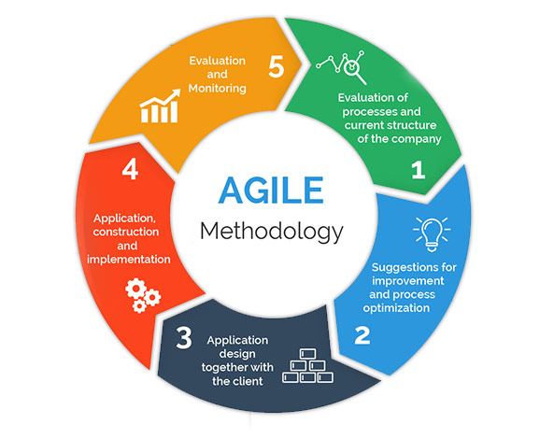

Figure 1. Agile Methodology Cycle

The team used the agile methodology to further explain the planning. Figure 1 shows the Agile Methodology Cycle wherein the team and the client managed to have an effective collaboration.

* + - * **Evaluation**

The team set up a meeting with the client for an interview to gather information from their current process to how effective their old solution is on solving their problem. This way, data gathering is easy and will be accessible to review for the team members.

* + - * **Brainstorming**

After gathering data, the team brainstormed and analyzed the client’s main problem to propose a solution for the company. The team had several meetings to discuss ideas for the solution and explored what software to use to create the online store.

* + - * **Designing**

When the brainstorming finalized, the team decided to design and program an online store for the company’s page to be accommodated by the customer’s inquiries about their products and services. The design, the overall interface of the online store, and the flow of the online store to be used by the user and the admin are created in this phase.

* + - * **Developing**

With the design of the online store finalized, the team will then develop the online store. This will be tested for the program and the responsiveness of the developed online store. Once done, the improvement of the design and the changes will be made if needed.

* + - * **Testing**

After developing the online store, the team and the administrator will then test the program and analyze for errors or bugs. This is where the administrator and the team evaluate the online store from different devices to make sure it will have the same interface without errors shown.

## Requirements Analysis

### Product Backlog / User Stories

|  |  |  |  |  |
| --- | --- | --- | --- | --- |
| **ID** | **IMPORTANCE** | **TITLE** | **USER STORY** | **ACCEPTANCE CRITERIA** |
| PBUS01 | 100 | Customer Inquiry | As a customer, I want to be able to inquire so that I know what items are available and to help me with my purchase | * Ability to contact the admin * Ability to check availability * Ability to click the view details |
| PUBUS02 | 100 | Manage Account | As a customer, I want to update my personal account details or to create a new account. | 1. Ability to create accounts 2. Ability to update contact details 3. Ability to login |
| PUBUS03 | 100 | Manage Orders | As a customer, I want to review my orders before proceeding to checkout/payment. | 1. Ability to select payment method 2. Ability to make payments 3. Ability to add/remove items on cart |
| PBUS04 | 100 | Manage Inventory | As a Store Manager, I will be able to manage the availability of the products. | * Ability to access the dashboard * Ability to generate inventory. |
| PUBUS05 | 100 | Manage website | As a Store Owner, I will be able to access, manage, update, and edit the website | * Ability to access the admin account * Ability to manage, update, and edit the website |
| PUBUS06 | 100 | View Reports on Dashboard | As the Store Owner and Store Manager, I want to view the overall business insights and company’s performance so that I can monitor how the business is doing. | * Ability to access the dashboard * Ability to update inventory, sales, and orders |

Table 1. Product Backlog/User Stories

### Event Tables

|  |  |  |  |  |  |
| --- | --- | --- | --- | --- | --- |
| **EVENT** | **TRIGGER** | **SOURCE** | **USE CASE** | **RESPONSE** | **DESTINATION** |
| Customer Inquiry | Customer inquiries for an order | Customer | Customer Inquiry | Requested Information Details | Customer & Store Owner |
| Manage account | Manage Account | Manage Account | Updated account details |
| Manage Orders | Process Order | Manage Orders | Order Details | Customer & Store Manager |
| Store Manager manages Inventory | Manage Inventory | Store Manager | Manage Inventory | Inventory Details | Store Manager |
| Store Owner manages website | Manage database | Store Owner | Manage Website | Updated system details | Store Owner |
| View Reports on Dashboard | View Reports |  | View  Dashboard | Display Dashboard Reports | Store Manager & Store Owner |

Table 2. Event Table

### **Use Case Diagram**

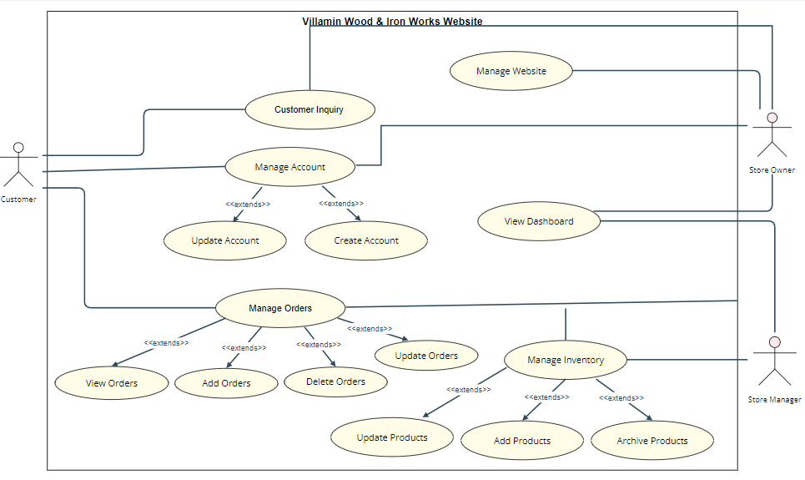

Figure 2. Use Case Diagram

### Use Case Full Description

|  |  |  |
| --- | --- | --- |
| **Use Case Name:** | Customer Inquiry | |
| **Scenario:** | Customer inquiries | |
| **Triggering Event:** | Customer inquiries for an order | |
| **Brief Description:** | Customer wants to check how many items and what are the items are available as well as services | |
| **Actors:** | Customer | |
| **Related Use Cases:** |  | |
| **Stakeholders:** | Customer, Store Owner | |
| **Preconditions:** | * Customer must be inside the website. * Customer must request for items availability | |
| **Postconditions:** | * Customer must be able to receive requested information details * Customer must be able to identify the total number of available items or stocks. | |
| **Flow of Activities:** | **Actor** | **System** |
| 1. Customer visits website 2. Customer inquiries for items, sales, and services | 1.1 System loads for the home page  2.1 System displays the requested inquiry |
| **Exception Conditions:** | 1. Customer cannot visit website if not on browser    1. System will display an error if system did not load for the home page 2. Customer cannot inquire if there’s no question about services    1. System will not display the requested inquiry if customer did not inquire. | |

Table 3. Use Case Description for Customer Inquiry

|  |  |  |
| --- | --- | --- |
| **Use Case Name:** | Manage Account | |
| **Scenario:** | * Customer wants to create an account * Customer wants to update their account | |
| **Triggering Event:** | Manage Account | |
| **Brief Description:** | * Customer creates a new account * Customer updates existing account | |
| **Actors:** | Customer | |
| **Related Use Cases:** |  | |
| **Stakeholders:** | Customer, Store Owner | |
| **Preconditions:** | * Customer must be online * Customer must be on the website | |
| **Postconditions:** | * Website will display the customer’s account details * Customer will be able to edit their account | |
| **Flow of Activities:** | **Actor** | **System** |
| 1. Customer visits the website 2. Customer clicks create account icon 3. Customer input details 4. Customer created account 5. Customer clicks update account 6. Customers edit account details 7. Customer saves account | 1.1 System loads for request  2.1 System displays create account interface  2.2 System verifies the details  2.3 New Account successfully added to the System Database  3.1 System displays update account interface  3.2 System verifies the details  3.3 System updated the account  details |
| **Exception Conditions:** | 1. Customer cannot create an account if offline.   1.1 Browser will display “No Internet Connection”   1. Customer cannot create an account if there is an existing account.   2.1 System will display “An email was used in using this account.”   1. Customer needs to confirm via email or phone number before finishing creating their account.   3.1 System will display “An email was sent to your inbox for account verification.” | |

Table 4. Use Case Description for Manage Account

|  |  |  |
| --- | --- | --- |
| **Use Case Name:** | Manage Orders | |
| **Scenario:** | Customer wants to order items | |
| **Triggering Event:** | Process Orders | |
| **Brief Description:** | Customer wants to order items | |
| **Actors:** | Customer | |
| **Related Use Cases:** |  | |
| **Stakeholders:** | Customer, Store Manager | |
| **Preconditions:** | * Customer must be on the website. * Customer must be logged in. * Customer must complete their items for the order. | |
| **Postconditions:** | * The customer’s order must be displayed to the system. * Customer must be able to checkout. * Customer must be able to complete an order. | |
| **Flow of Activities:** | **Actor** | **System** |
| 1. Customer visits website 2. Customer clicks search for items 3. Customers selected items will be added to the cart 4. Customer clicks view orders 5. Customer clicks update orders 6. Customer selects checkout | 1.1 System loads for request  2.1 System displays searched items  3.1 System adds selected items into the cart  3.2 System displays orders  3.3 System updates orders  4.1 System process order  5.1 System generates transaction details |
| **Exception Conditions:** | 1. Customer cannot place an order if offline.   1.1 Browser will display “No Internet Connection”   1. Customer cannot place an order without an account   2.1 System will display an error: “The user has not created an account.”   1. Customer cannot checkout without one selected item.   3.1 The checkout button cannot be clicked. | |

Table 5. Use Case Description for Manage Orders

|  |  |  |
| --- | --- | --- |
| **Use Case Name:** | Manage Inventory | |
| **Scenario:** | Store Manager checks and updates website inventory | |
| **Triggering Event:** | Manage Inventory | |
| **Brief Description:** | The Stores Manager checks how many and what are the items are available in the inventory. | |
| **Actors:** | Store Manager | |
| **Related Use Cases:** |  | |
| **Stakeholders:** | Store Manager | |
| **Preconditions:** | * The Store Manager must have access to the system. | |
| **Postconditions:** | * The Store Manager must be able to view the inventory * The Store Manager must always update inventory. | |
| **Flow of Activities:** | **Actor** | **System** |
| 1. Store Manager clicks inventory  2. Store Manager updates inventory | 1.1 System displays inventory  2.1 System inventory updated successfully |
| **Exception Conditions:** | 1. Store Manager cannot update if not connected to the internet.   1.1 Browser will display “No Internet Connection”   1. The Store Manager cannot update if not logged in.   2.1 System will display “Administrator not logged in. Cannot update the inventory.” | |

Table 6. Use Case Description for Manage Inventory

|  |  |  |
| --- | --- | --- |
| **Use Case Name:** | Manage Website | |
| **Scenario:** | Store Owner manages the system’s database. | |
| **Triggering Event:** | Managing Database | |
| **Brief Description:** | Store owners decide to customize, edit, and make changes in the system. | |
| **Actors:** | Store Owner | |
| **Related Use Cases:** | View orders and inventory and view Dashboard | |
| **Stakeholders:** | Store Owner | |
| **Preconditions:** | 1. Store Owner must have access to the system. 2. Store Owner must consult the client before making any changes or updates to the system. | |
| **Postconditions:** | * Store Owner must view changes and updates in the system. | |
| **Flow of Activities:** | **Actor** | **System** |
| 1. Store Owner logs in 2. Store Owner views home page 3. Store Owner clicks dashboard 4. Store Owner updates system details. | * 1. System loads for request   1.2 System displays login tab  2.1 System displays successfully  logged in prompt  2.2 System loads dashboard  3.1 System updates changes made. |
| **Exception Conditions:** | * + - 1. Store Owner cannot view the system if offline.   1.1 Browser will display “No Internet Connection”   * + - 1. Store Owner cannot access the system if the user is not an employee   2.1 System will display “Inaccessible account.”   * + - 1. Store Owner cannot login if the user does not have any Store Owner account.   3.1 System will display “No existing administrator account.” | |

Table 7. Use Case Description for Manage Website

|  |  |  |
| --- | --- | --- |
| **Use Case Name:** | View Dashboard | |
| **Scenario:** | Store Owner views product and purchase report | |
| **Triggering Event:** | View Report | |
| **Brief Description:** | Store Owner views product and purchase report through the dashboard on the website | |
| **Actors:** | Store Owner | |
| **Related Use Cases:** |  | |
| **Stakeholders:** | Store Owner and Store Manager | |
| **Preconditions:** | * Store Owner must be logged in * Reports should be reflected in the store manager and store owner’s dashboard | |
| **Postconditions:** | * Store owner and store manager must be able to see the reports on the dashboard | |
| **Flow of Activities:** | **Actor** | **System** |
| 1. Open System 2. Logs in 3. Home page 4. Store Owner clicks dashboard page 5. Store Owner view reports 6. Refresh page 7. Checks for changes after refreshing | 1.1 System loads for request  2.1 System displays login tab  3.1 System displays successfully logged in prompt  3.2 System displays dashboard  4.1 System displays reports   * 1. System refreshes the contents   5.2 System displays updated content |
| **Exception Conditions:** | 1. Cannot view dashboard when offline    1. Browser will display “No Internet Connection” 2. Cannot view reports if not logged in    1. System will display “Administrator not logged in. Cannot view reports.” 3. Cannot login if the user is not the Store owner or store manager.    1. System will display “Inaccessible account. No existing   administrator account.” | |

Table 8. Use Case Description for View Dashboard

## Gap Analysis

|  |  |  |  |
| --- | --- | --- | --- |
| Product Backlog ID | Current System | Proposed Changes | Impact |
| PRBL01 | Manual Ordering & Facebook Page | Online Store | To increase customer reach and company’s profit. |
| PRBL02 | Actual Receipt | Digital Receipt | To lessen or remove losses of the actual receipt. |

Table 9. Gap Analysis

## System Analysis and Design

### Context Flow Diagram

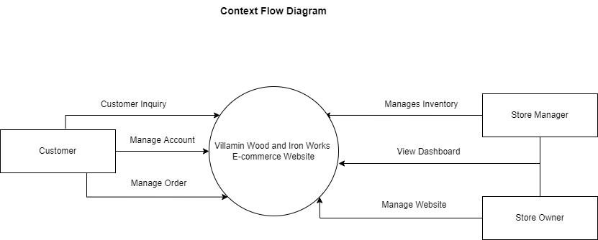

Figure 3. Context Flow Diagram

### Data Flow Diagram

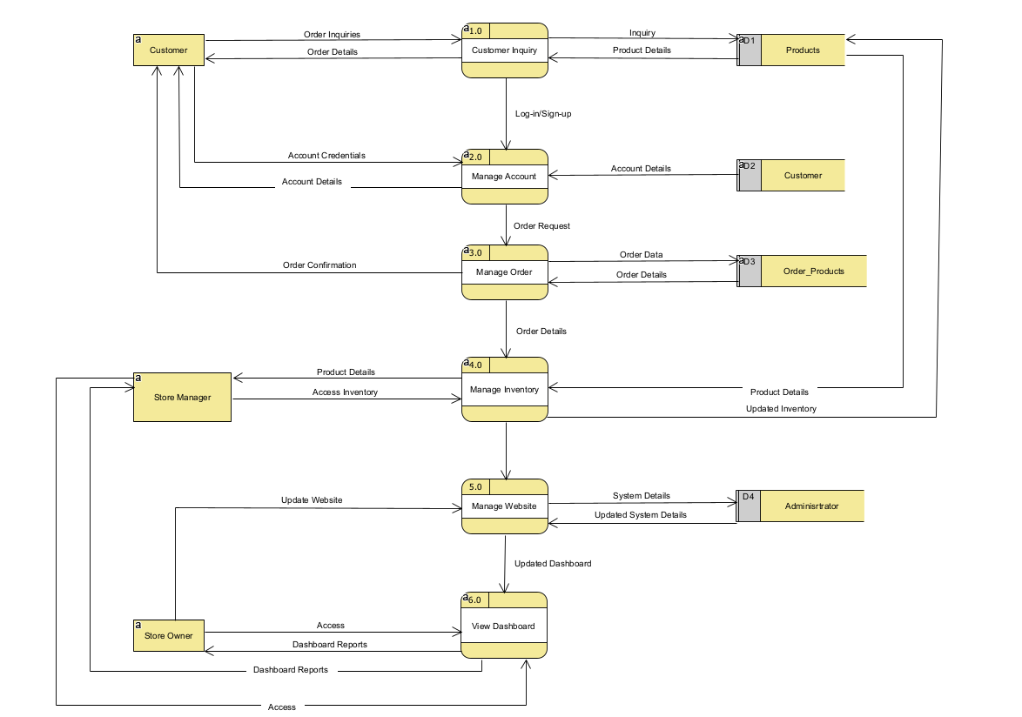

Figure 4. Level 0 - Data Flow Diagram

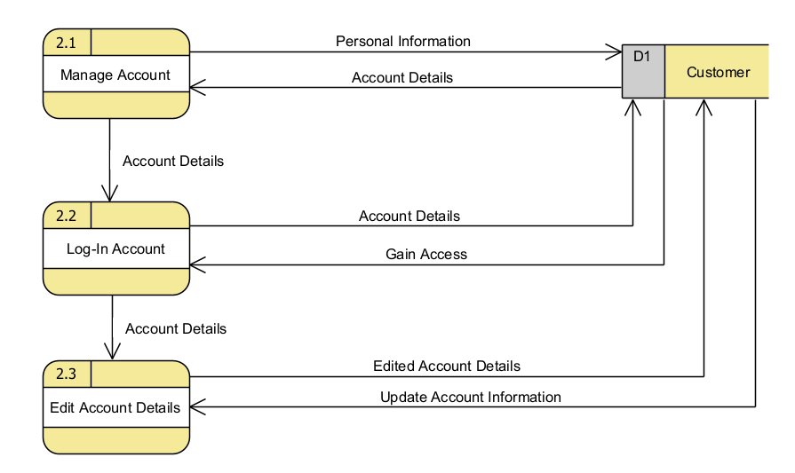

Figure 5. Level 1 - Manage Account (Customer) Data Flow Diagram

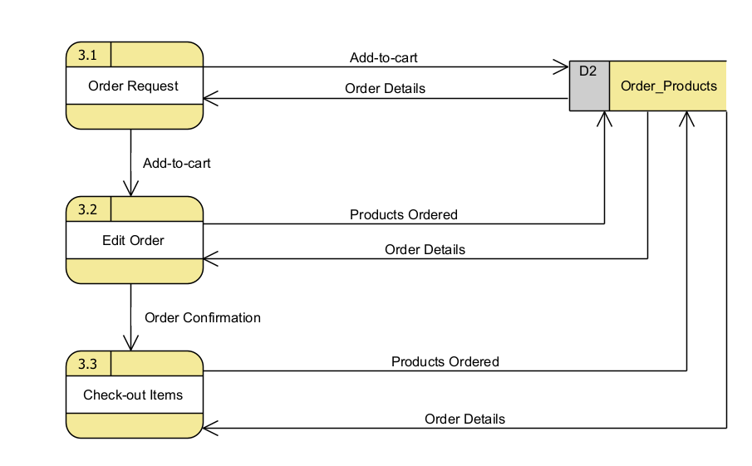

Figure 6. Level 1 - Manage Order (Customer) Data Flow Diagram

### Entity-Relationship Diagram

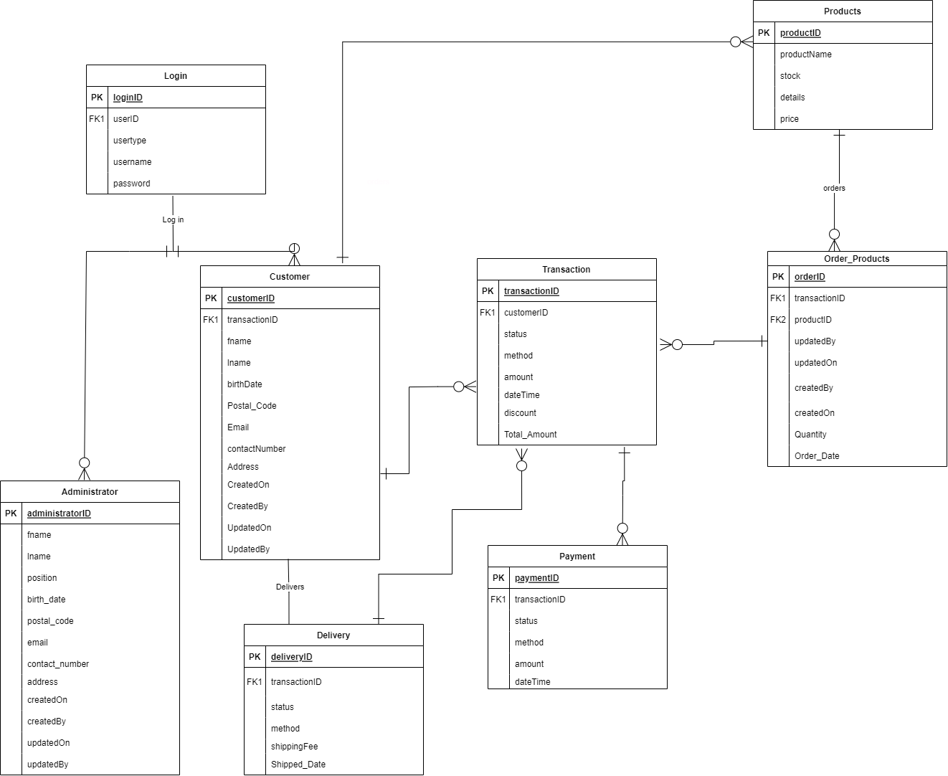

Figure 7. Entity-Relationship Diagram

### Activity Diagram

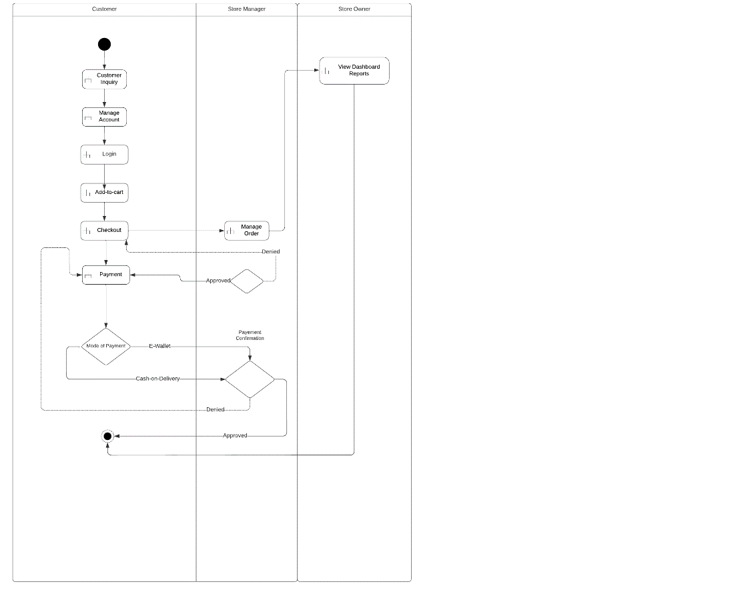

Figure 8. Activity Diagram

### Object Diagram

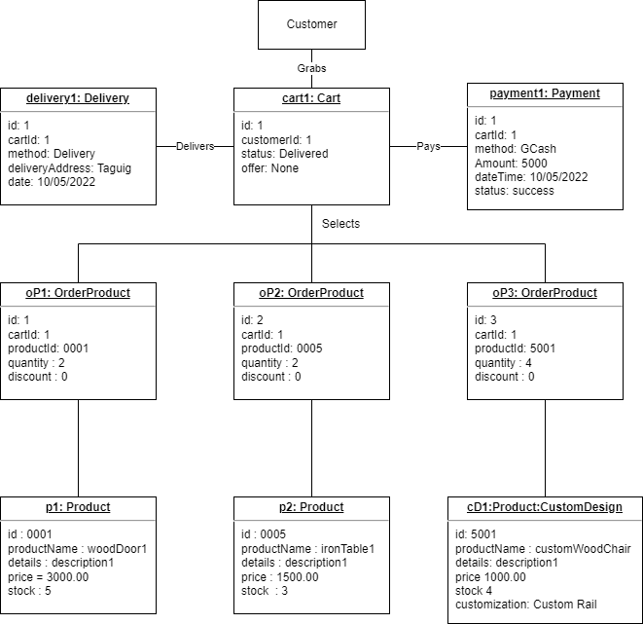

Figure 9. Object Diagram

### Class Diagram

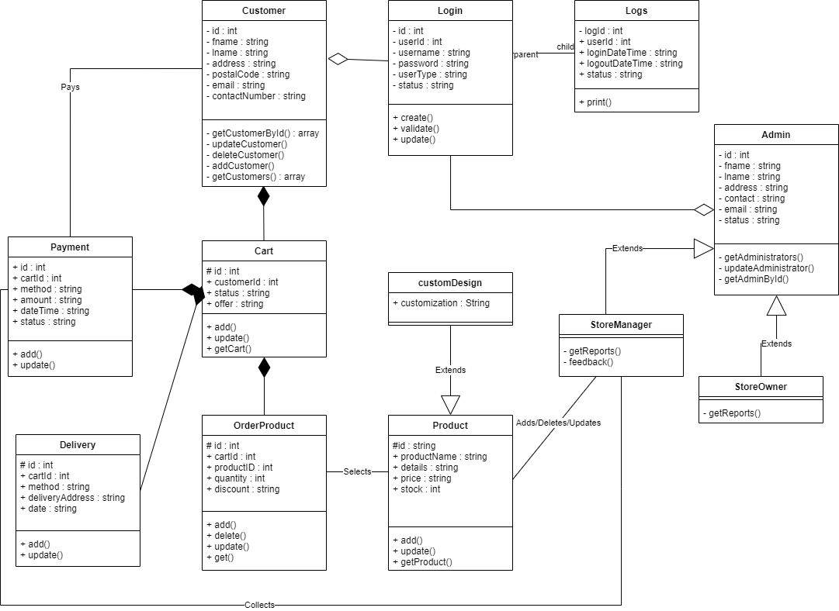

Figure 10. Class Diagram

### Sequence Diagram

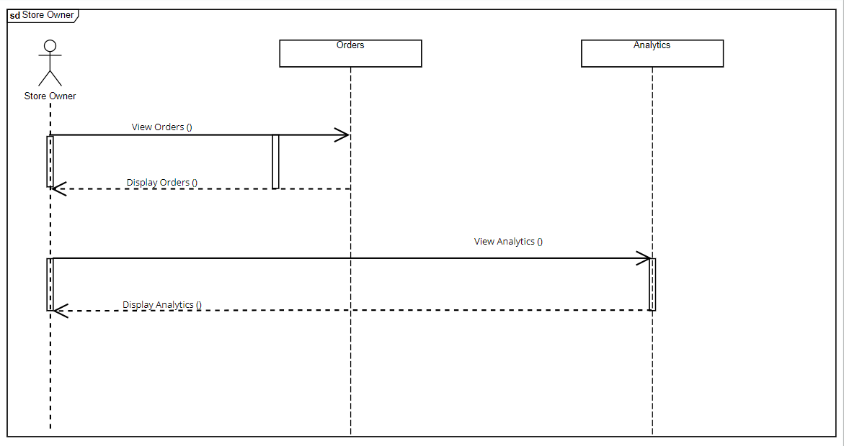

Figure 11. Sequence Diagram for Store Owner

Figure 12. Sequence Diagram for Store Manager

Figure 13. Sequence Diagram for Customer Account

Figure 14. Sequence Diagram for Customer Inquiry

Figure 15. Sequence Diagram for Ordering

Figure 16. Sequence Diagram for Feedback

### State Machine Diagram

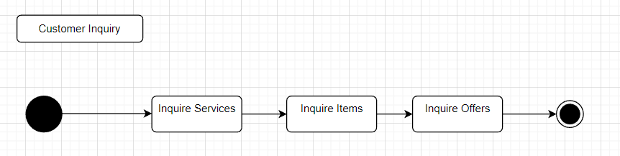

Figure 17. State Machine Diagram for Customer Inquiry

Figure 18. State Machine Diagram for Manage Account

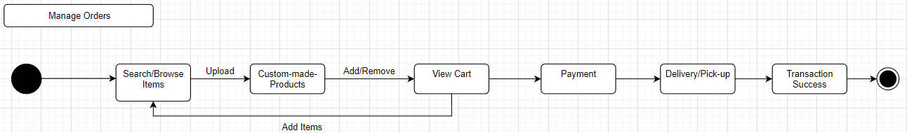

Figure 19. State Machine Diagram for Manage Orders

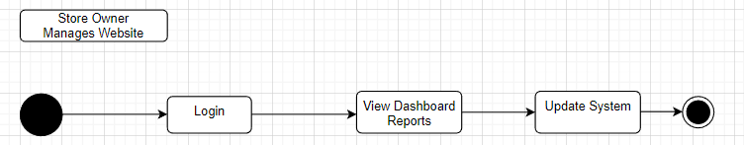

Figure 20. State Machine Diagram for Store Owner Manages Website

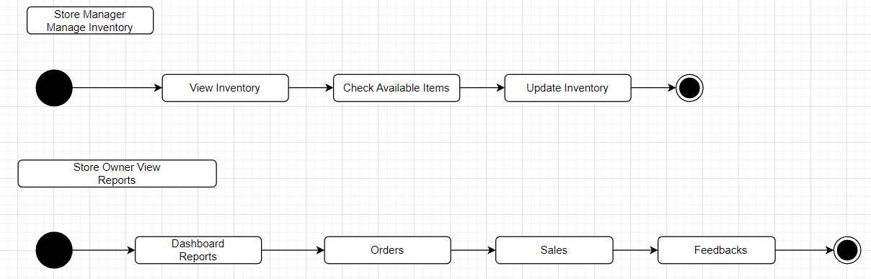

Figure 21. State Machine Diagrams for Store Manager Manages Inventory and Admin View Dashboard Reports

### Package Diagram

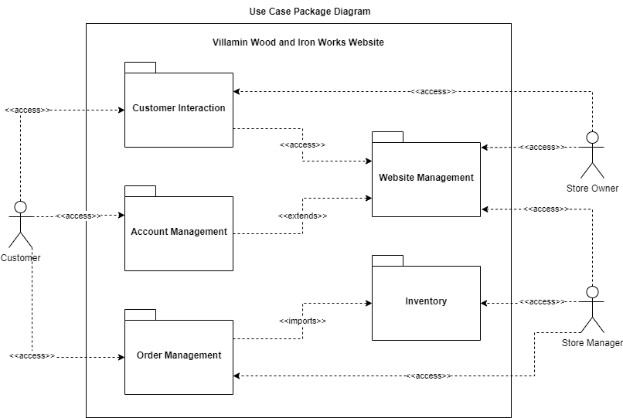

Figure 22. Use Case Package Diagram

### Component Diagram

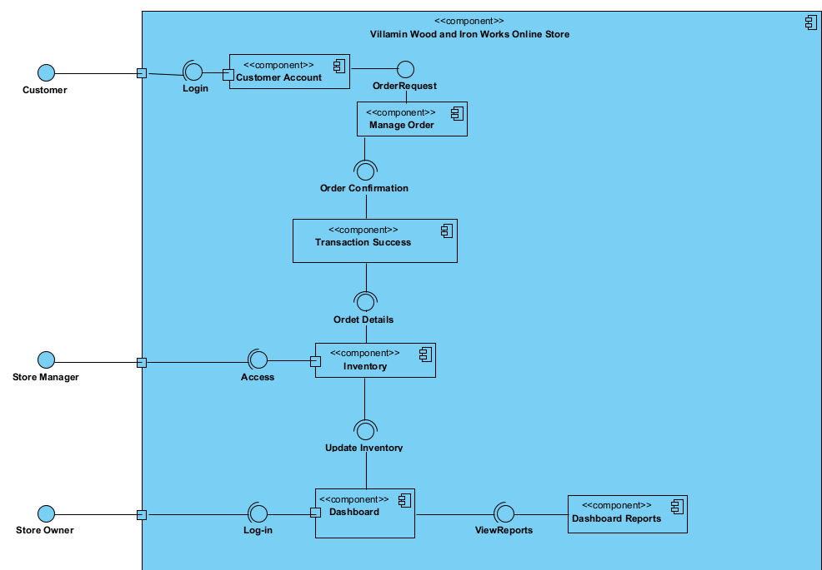

Figure 23. Component Diagram

### Deployment Diagram

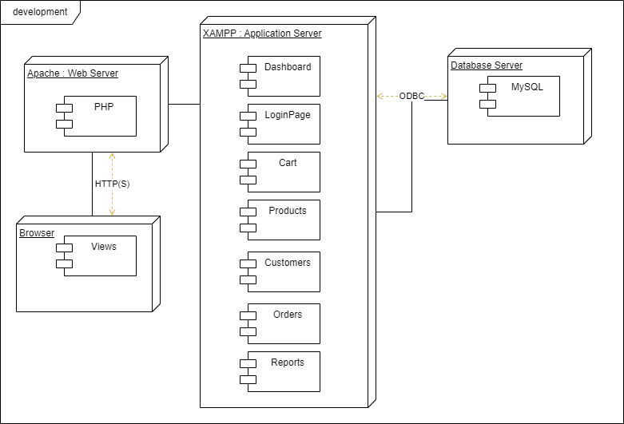

Figure 24. Deployment Diagram

# Results and Discussion

This chapter presents findings and a discussion related to relevant outcomes. It concentrates on the topic of a tactical document created to record and monitor the features anticipated for a future release. There will also be a discussion of a system designed to have a specific field of vision.

## Release Plan

|  |  |  |
| --- | --- | --- |
| Customer | Store Manager | Store Owner |
| 1. Customers can view the entire website. They can only place their order and proceed to payment once they have created an account. 2. Customers can place their orders and provide their personal information. 3. Customers can check out and choose their desired mode of payment. 4. Customers will choose the receiving method whether it will be delivered or self-pickup 5. Customers will receive an official receipt when they receive the product 6. Customers can comment or create a post in the Customer feedback and forum. 7. Customers can import sample designs and fill out order forms for custom-made designs. 8. Customers will have the option of product installation. 9. Customers can use the website efficiently. | 1. Store Manager can see orders and inquiries from the customers. 2. Store Manager can process the orders of the customers. 3. Store Manager will upload inventory 4. Store Manager can update product stocks 5. Store Manager will provide quotations by sending it to the customer using email or via chat through the company’s fb page. 6. Store Manager will scan and check the custom-made form filled out by the customers. | 1. Store Owner can view the design and concept of the website. 2. Store Owner can test, evaluate, and suggest changes in the structure of the website. 3. Store Owner can provide their thoughts or comments about the future website. 4. Store Owner will filter and sort comments or feedback of the customers. (Remove insensitive comments) |

Table 10. Release Plan

## Prototype

Figure 25. Website Home Page

Figure 26. Website Product Page (Existing Designs)

Figure 27. Website Product Page (Custom Design)

Figure 28. Website Customer Forum Page

Figure 29. Frequently Asked Questions (FAQs) Page

Figure 30. About the Company Page

## Use Classes and Characteristics

|  |  |
| --- | --- |
| Roles | Description |
| Client’s Customer | This user purchases the company’s product and/or service and provides feedback for the developed project. |
| Store Manager | This user is responsible for processing the orders of the customer and updating the inventory. |
| Client/Store Owner | This user is the owner of the company that receives the customers feedback and shares it with the team on what to adjust and develop. |
| MLNSD Team | This user adjusts and develops the project according to customer’s and client’s feedback. |
| The Adviser | This user approves or disapproves the request made by the representatives of the team he/she manages. |

Table 11. Use Classes and Characteristics

# Conclusion

Since 1983, Villamin Wood and Iron Works have been in operation. Throughout its history, it has encountered difficulties, particularly with its marketing strategies and client reach. The team then produced a solution that will aid in the expansion of their business. An online store that will simplify Villamin Wood and Iron Works' business company. An option for customized products, inventory management, customer forums and an about us page will all be added to make this possible. Due to a lack of fulfillment, the plan has not yet commenced. The team intends to launch the entire system for the following iteration after the features are completed and finalized.

# References

|  |  |
| --- | --- |
| [1] | S. McLachlan and C. Newberry, "22 benefits of Social Media for Business," 29 June 2021. [Online]. Available: https://blog.hootsuite.com/social-media-for-business/. |
| [2] | B. Lal, E. Ismagilova, Y. K. Dwivedi and S. Kwayu, "Return on Investment in Social Media Marketing: Literature Review and Suggestions for Future Research," in *Digital and Social Media Marketing*, Springer, Cham, 2019, pp. pp 3-17. |
| [3] | A. Peruta and A. B. Shields, "Marketing your university on social media: a content analysis of Facebook post types and formats," 2018. [Online]. |
| [4] | E. Gnanadhas, "Online Shopping - An Overview," June 2014. [Online]. Available: https://www.researchgate.net/publication/264556861_Online_Shopping_-_An_Overview. |
| [5] | M. A. Adam and F. Ahmed, "Contemporary Digital Marketing Practices in Food Chains in Pakistan," *International Journal of Business and Management,* pp. 72-119, 2017. |
| [6] | M. M. Al-Debei, M. N. Akroush and M. I. Ashouri, "Consumer Attitudes Towards Online Shopping: The Effects of Trust, Perceived Benefits, and Perceived Web Quality," October 2015. [Online]. Available: https://cutt.ly/fNvYXFX. [Accessed 29 October 2022]. |
| [7] | J. Lou, S. Ba and H. Zhang, "The Effectiveness of Online Shopping Characteristics and Well-Designed Websites on Satisfaction," December 2012. [Online]. Available: https://cutt.ly/lNvY0Ig. [Accessed 29 October 2022]. |

# Appendices

## Appendix A: Project Vision

|  |  |
| --- | --- |
| For | The administrator and customers of Villamin Wood and Iron Works |
| Who | Desire to have a platform to improve their communication effectively, organize their database, store receipts and records safely, and upgrade their advertising of product. |
| The | Villamin Wood and Iron Works System is an online store |
| That | Enable the customers to transact efficiently with the owners. |
| Unlike | The competitors of Villamin Wood and Iron Works use Facebook for their businesses wherein they have a prospect to gain customers. |
| Our product | offers high quality content, responsive design, and services to provide satisfaction to customers which will be achieved with the features of the web system such *about us page, categorized list of products, online custom-made design attachment, customer forum and feedback page, modules and analytics* that will help the business. |

Table 12. Project Vision

## Appendix B: Schedule

Figure 31. MLNSD's Project Timeline

## Appendix C: Product Roadmap

(

*Updated product roadmap file here. Make sure that content is readable*

)

## Appendix D: Users’ Manual

Figure 32. Search Results Page

Figure 33. Product Information Page

Figure 34. Product Cart Page

Figure 35. Edit Profile Page

Figure 36. Purchases Page

Figure 37. Login and Sign-Up Page

## Appendix E: Team Meetings

* September 16, 2022
* Duration: 32m 25s

Figure 38. Meeting with Adviser - September 16, 2022

* October 12, 2022
* Duration: 20m 45s

Figure 39. Meeting with Adviser - October 12, 2022

* October 18, 2022
* Duration: 21mins 19s

Figure 40. Meeting with Consultant - October 18, 2022

## Appendix F: Source Code

Figure 41. MLNSD's GitHub Repository

<https://github.com/seans888/MLNSD.git>